

**School of Computing**

**Faculty of Engineering**

**UNIVERSITI TEKNOLOGI MALAYSIA**

**DATA STRUCTURE & ALGORITHMS**

**(SECJ2013)**

**SEMESTER 1 2022/2023**

**Mini PROJECT Documentation**

**Directories and Files Management System**

**By**

**AYOUB ENNABILI (A20EC4054) – Leader**

**MD ABU TALHA IBNA RIAZ HASSAN (A20EC3022)**

**MUSAB MUDATHIR (A20EC4077)**

**IFTEKHAR UDDIN AHMED (A20EC3016)**

**SECTION 08**

**Lecturer:**

**Dr.** [**BANDER ALI SALEH AL-RIMY**](https://elearning.utm.my/22231/user/view.php?id=21709&course=14571)

**Date: 20th January, 2023**

# PART 1 : INTRODUCTION

## Synopsis Project:

Our project realizes a Directories and Files Management system. And as the name implies, it is a system that allows its users to manage a set of directories and files in a tree hierarchy structure. The system implements various data structures. First, this program implements the **tree data structure** to represent the hierarchy structure of directories and sub-directories contained. It also implements the **queue data structure** to store the files being inserted by the user that will be created in a certain directory. The files inserted in the queue will be created in the directory one by one following First In First Out. Each directory implements the **linked list data structure** to store the list of files contained in each directory. Additionally, the system provides the user with functionality similar to the undo operation using the **stack data structure**. Like the undo feature, the stack keeps track of the directories navigation history. The user can thus go back to the previous/precedent directory using the history saved in the stack. **Arrays** are also used in the system to store the chain of files that are pending to be created inside a certain directory.

Our system provides the user with the ability to display the tree for directories in a well visualized way, and also navigate and go from one directory to another following the user’s choice. The user can use the visualization to know directories present inside the tree and their hierarchy structure. Additionally, the navigation is eased as the system is able to track the navigation history of the user, and allows him to go back to previous directories easier and faster than doing that through selecting the directory manually. Furthermore, the system is able to provide the freedom for its users to add new directories, add new files inside a certain directory, rename the directories and files, and delete them. The user can also choose to display the files located in a certain directory.

## Objective of The Project

The objective of this project is to create a system that allows users to efficiently manage and organize a set of directories and files in a tree hierarchy structure. The system utilizes various data structures, such as the tree data structure to represent the hierarchy of directories, the queue data structure to store a queue of files pending for creation following FIFO, the linked list data structure to store files within each directory, and the stack data structure to provide the go back functionality. The system also provides a well-visualized way to display the tree of directories and allows for easy navigation and the ability to add, rename, and delete directories and files. It also tracks the user's navigation history to make it easy for the user to go back to previous directories. The project's goal is to make it easy for users to manage their files and directories efficiently.

# PART 2 : SYSTEM ANALYSIS AND DESIGN (USE CASE, FLOWCHART AND CLASS DIAGRAM)

## 2.1 System Requirements

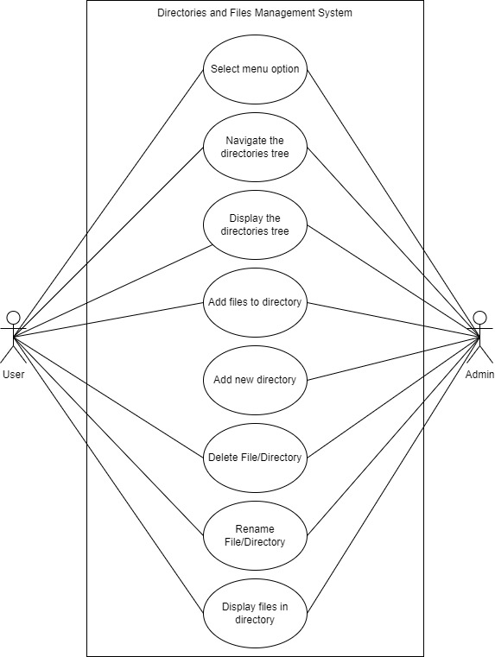

Figure 1 : Use Case Diagram for Directories and Files Management System

**Use Case Description for Directories and Files Management System**

The system users are: Admin and User.

|  |  |
| --- | --- |
| **Actor** | **Task** |
| Admin | The Admin has the highest role in the system, which permits him to fully manage directories and files by adding, deleting, renaming and displaying each one of them through the system’s menu. The Admin can also display the directories tree and perform the basic navigation functions like searching/going to certain directories, and going back to the previous directories. |
| User | The User can use the system’s menu to display the directories tree and perform the basic navigation functions like searching/going to certain directories, and going back to the previous directories. The User can also add files to a chosen directory and rename them. |

**Detail Description for Each Use Case**

The system has 8 main use cases

|  |  |
| --- | --- |
| **Use Case** | **Purpose** |
| Select menu option | Provides operations options for the user to choose from to perform a certain operation in the system. |
| Navigate the directories tree | Allows the user to navigate in the tree and go to the chosen directory. |
| Display the directories tree | Prints the directories tree in a structured and organized way to show the user the hierarchy of the directories in a well visualized manner. |
| Add files to directory | Updates the list of the files in a certain directory by adding the inputted files to that directory. |
| Add new directory | Adds a new directory to a certain place in the tree structure. |
| Delete File/Directory | Allows the user to delete a chosen file or directory. |
| Rename File/Directory | Renames the chosen file or directory with the new name entered by the user. |
| Display files in directory | Displays a list of all the files located in the directory. |

## 2.2 System Design

**Class Diagram of the system:**

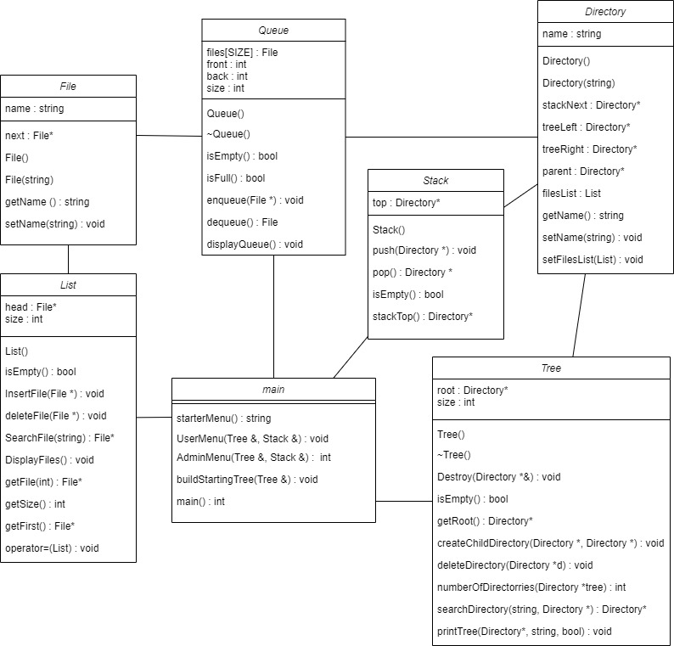

Figure 2: Class Diagram for Directories and Files Management System

**Algorithm: Flowchart for each module**

**Flowchart 1: Search for/Go to a directory**

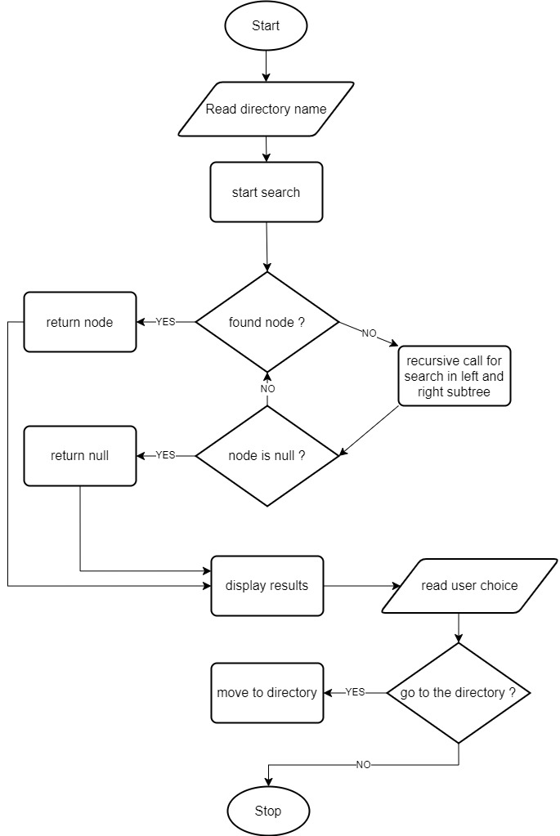

**Flowchart 2: Display the directories tree**

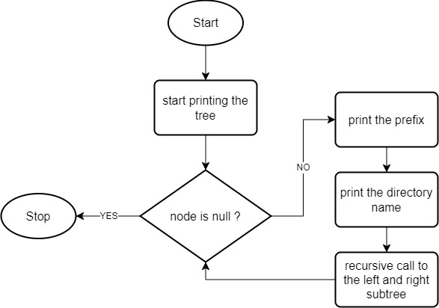

**Flowchart 3: Go back to previous directory**

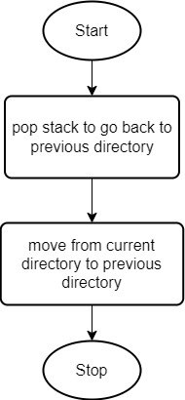

**Flowchart 4: Add files to current directory**

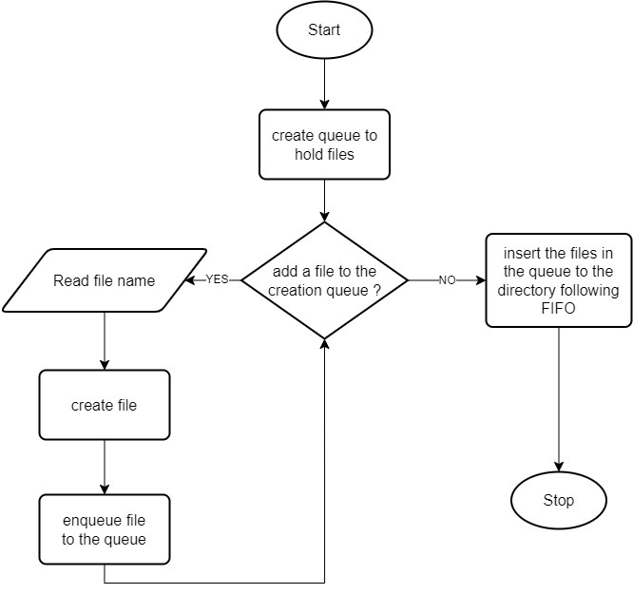

**Flowchart 5: Add new directory**

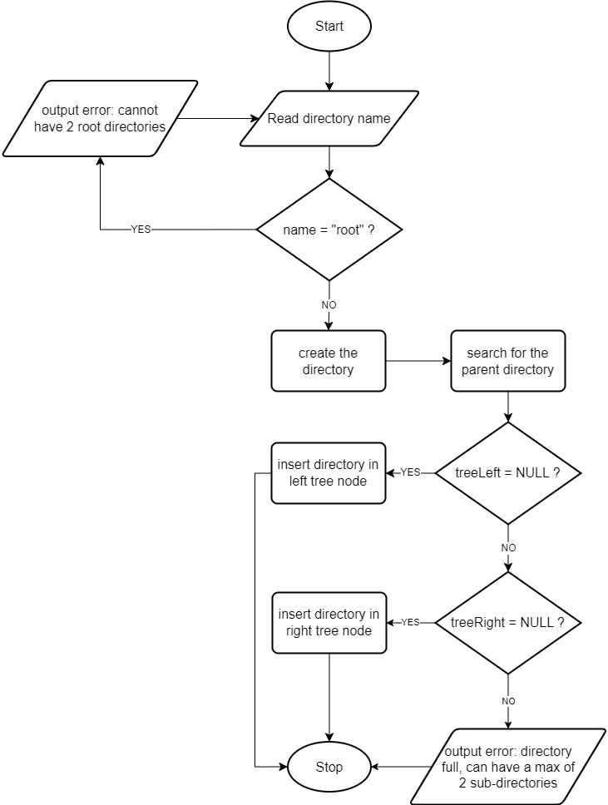

**Flowchart 6: Delete File/Directory**

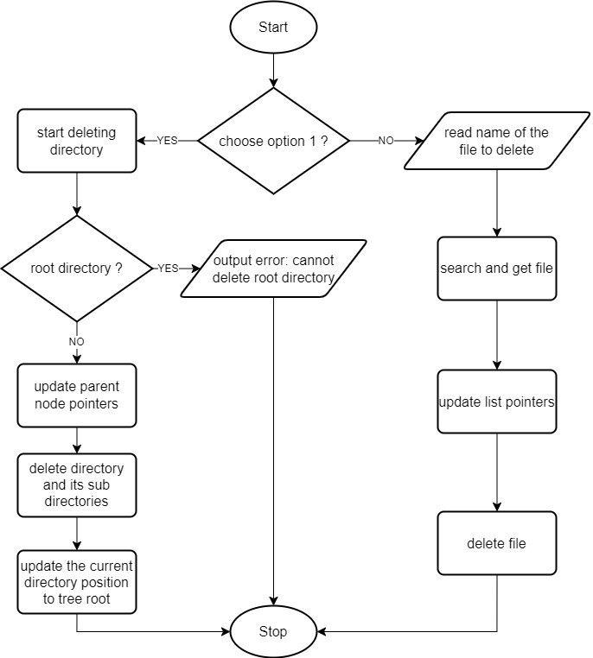

**Flowchart 7: Rename File/Directory**

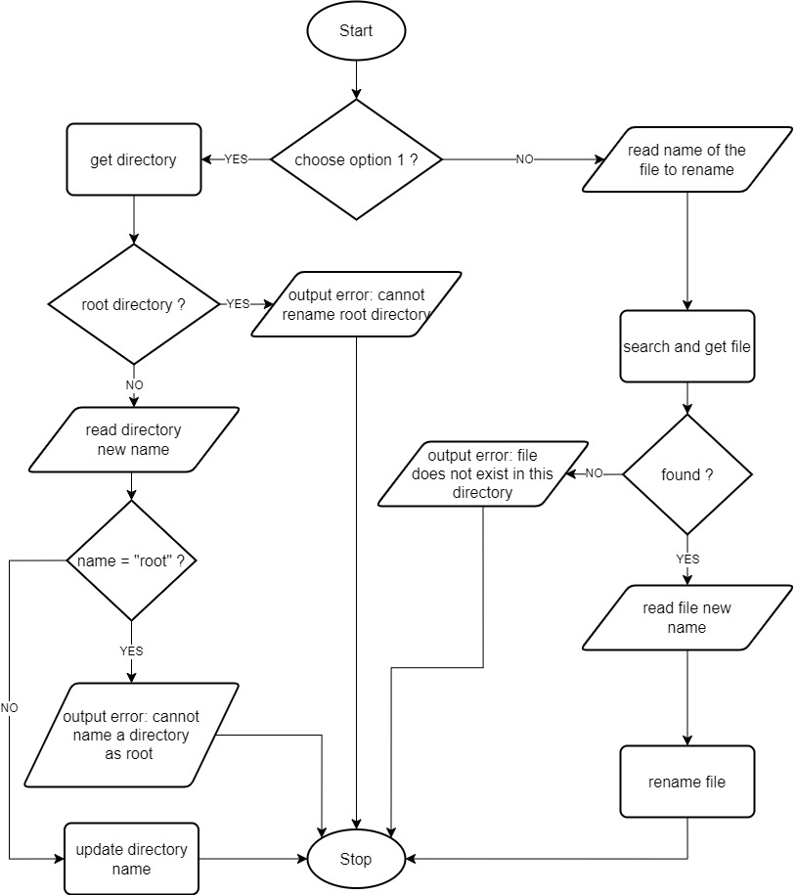

**Flowchart 8: Display Files of the current Directory**

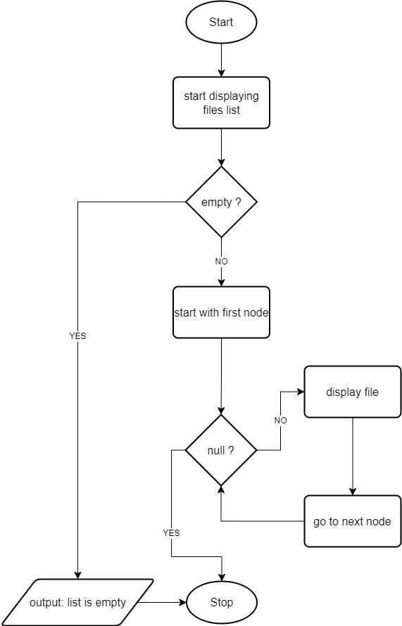

# PART 3 : SYSTEM PROTOTYPE

# 

Screen 1: The system asks if the user is an admin or a user

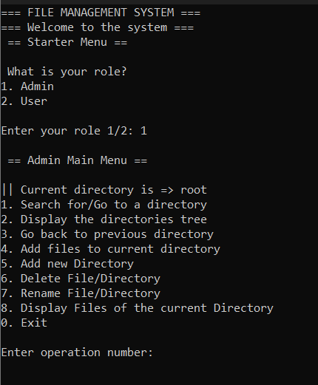

Screen 2: If the admin inputs ‘1’. The admin menu pops up and asks the admin to do one of the mentioned operations

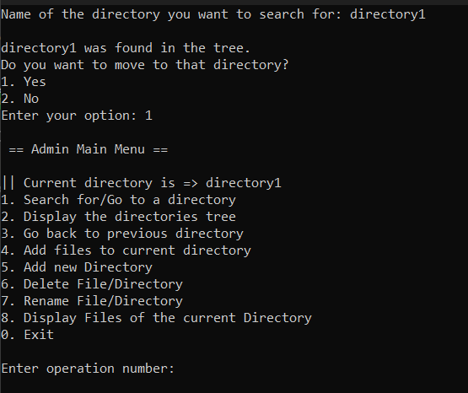

Screen 3 : if the admin inputs 1, “Search for/Go to a directory” the system asks the admin to input a directory name. If the directory exists the system asks if the admin wants to move into that directory. If the admin inputs “yes” the admin will be moved to that directory. And the menu will be printed again with the current directory visible.

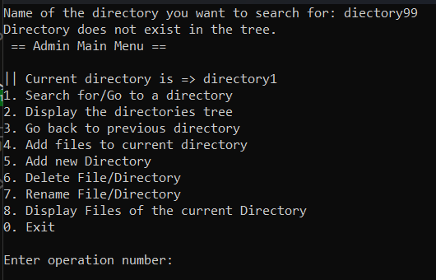

Screen 4: if the directory does not exist, this screen will be shown

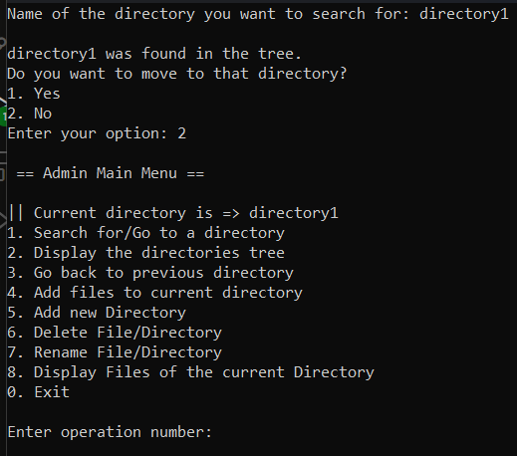

Screen 5: if the admin just wants to see if a directory is available in the tree and they do not want to move into that directory, this screen is shown

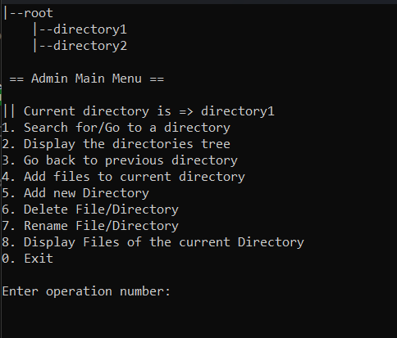

Screen 6: If the admin does operation 2 in the main menu, which is “Display the directories tree”, the tree will be displayed as shown above

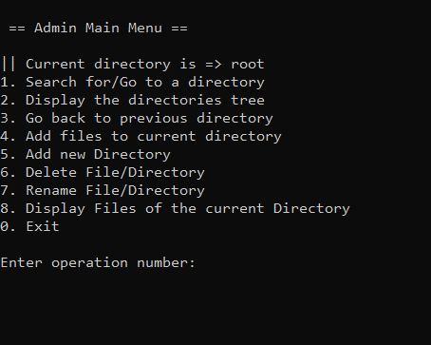

Screen 7:  if the admin does operation 3 in the main menu, which is “Go back to previous directory” the current directory will change and go back to the previous directory. Previously the current directory was directory was “directory1”, now the current directory is “root”

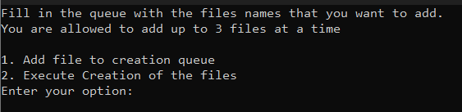

Screen 8 : if the admin wants to add files to the current directory, then he will input 4 in the admin main menu. Then this screen will be shown. Up to 3 files can be added at a time.

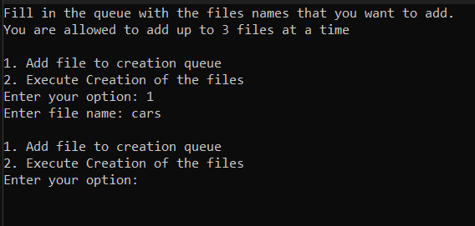

Screen 9: if the admin inputs 1, the system asks for the file name

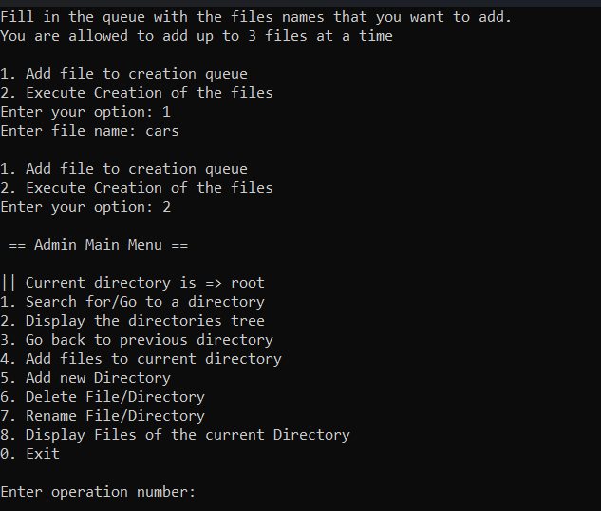

Screen 10: If the admins inputs 2, “Execute creation of the files”. The files in the queue will be added to that directory and the main menu will be shown

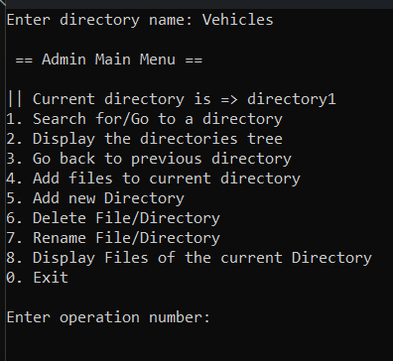

Screen 12: In the main menu, if the admin inputs 5 to add a new directory, the system will ask for the directory name and that directory will be created

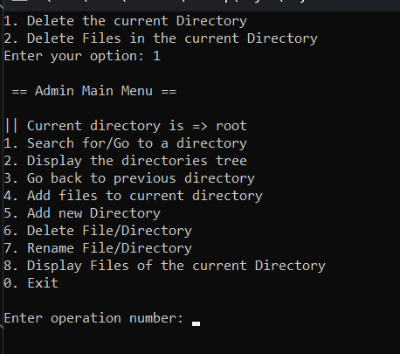

Screen 13: In the main menu, if the user presses 6, the system asks if they want to delete the current directory or if they want to delete files in the current directory. Here the admin deletes the current directory

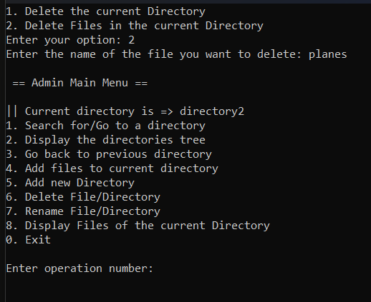

Screen 14: Here the admin is deleting the files of the current directory. First the admin inputs 6 in main menu. Then system asks if they want to delete the current directory or if they want to delete the files of the current directory. If the admin inputs 2, the system asks for the filename that is to be deleted.

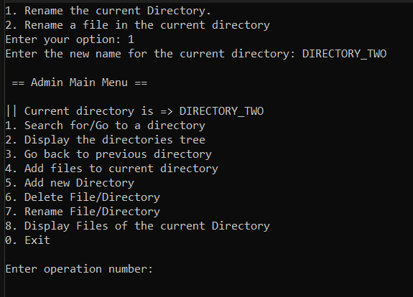

Screen 15: Here in the main menu, if the admin inputs 7 to rename the current directory/ files in the current directory. The system asks the admin if they want to rename the current directory or the current files in the directory. Here the admin inputs 1, so the system asks the new name for the directory.

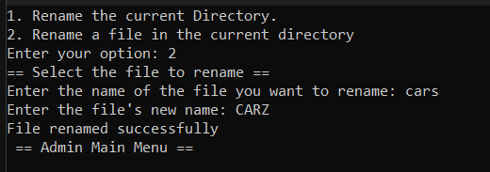

Screen 16: Here the admin now wants to change the name of a file in the current directory, so he presses 2. The system asks for a file to rename. Then after inputting a new name, the chosen file’s name gets changed.

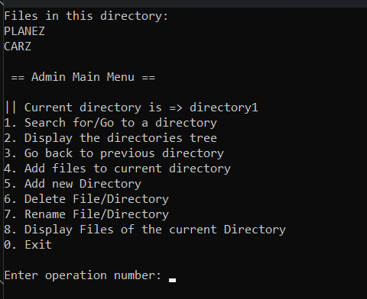

Screen 17: If the admin inputs 8 in the main menu, the files of the current directory will be displayed

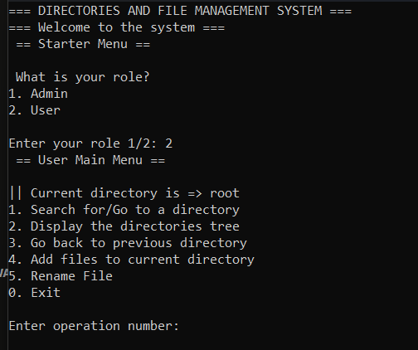

Screen 18: If the user wants to use the system, they input 2 in the starter menu and the user main menu will be displayed

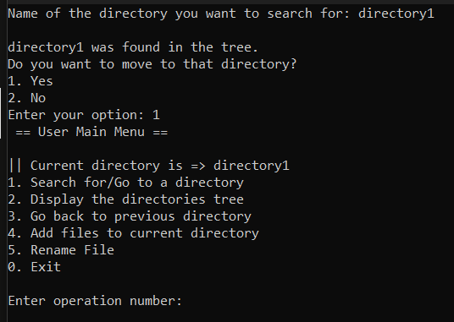

Screen 19: If the user inputs 1 in the user main menu, the system then asks for the directory that they want to search for. If the directory is found the system asks the user if they want to move into that directory or not. Here the user says yes by inputting 1. Then the menu is shown again with current directory being directory1

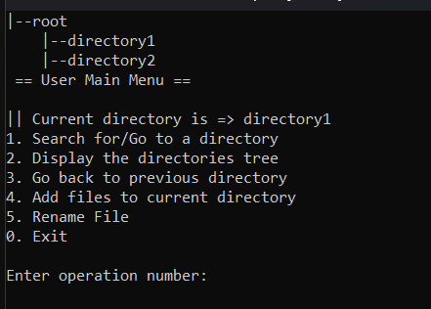

Screen 20: In the user main menu, if the user inputs 2, the directory trees are displayed.

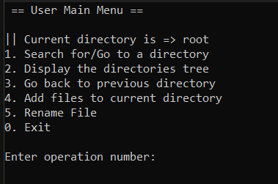

Screen 21: Then again in the user main menu, the inputs 3. The current directory changes to the previous directory and the menu is displayed, Here in the main menu the current directory is now root, previously it was directory1

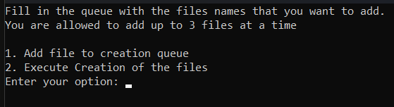

Screen 22: In the user main menu if the user inputs 4, to add files to the current directory, this menu will be shown

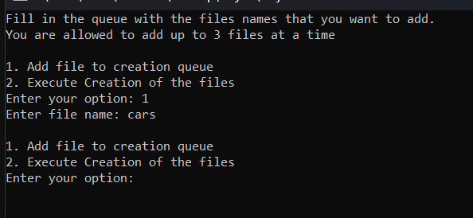

Screen 23 : Here the user inputs 1, to add a file. The system then asks for the file name.

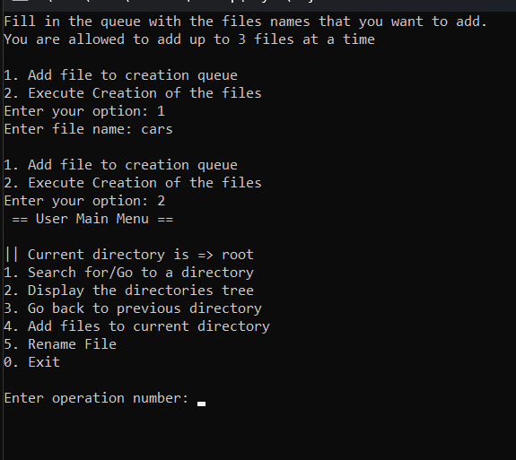

Screen 24: After adding the file name, the user now inputs 2 to execute creation of the file. The files will be added and the main menu will be shown.

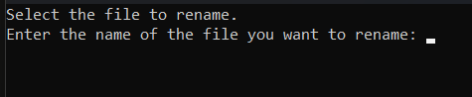

Screen 25: In the main menu if the users inputs 5 to rename a file, this screen will be shown. Here the system asks for the file name that the users want to rename.

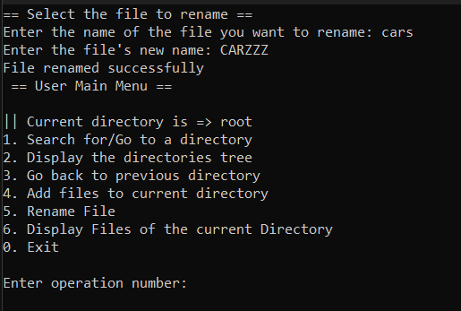

Screen 26: Here the user enters the file name of the file he wants to rename. Then he enters the new name of the file. Then the file name gets updated

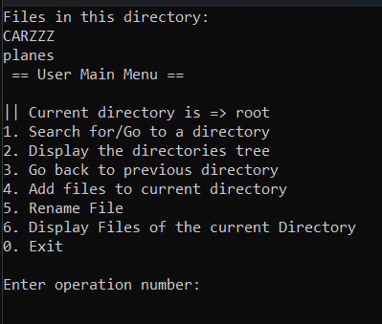

Screen 27: In the main menu if the user inputs 6 the files in the current directory will be displayed

# PART 4 : DEVELOPMENT ACTIVITIES

|  |  |  |  |  |
| --- | --- | --- | --- | --- |
| **Meeting Date** | **Members Participate in the meeting** | **Activity** | **Task for each**  **member** | **Task Achieved (Yes/No)** |
| 16th January, 2023 | Ayoub, Talha, Musab, Iftekhar | Brainstorm ideas about a suitable system to implement in the project. And start making the skeleton of the program. | -Find ways to implement each data structure  -Implement operations needed for each data structure | Yes |
| 17th January, 2023 | Ayoub, Talha, Musab, Iftekhar | Start developing the system and the modules | -Start implementing the system  -Implement the modules | Yes |
| 19th January, 2023 | Ayoub, Talha, Musab, Iftekhar | Test the system and fix problems found. And start documenting the system in the report | -Test each module  -Fix problems identified  -Start making the report for the system documentation | Yes |
| 20th January, 2023 | Ayoub, Talha, Musab, Iftekhar | Perform final testing to the system and Finalize the report | -Do final tests to ensure there are no problems left in the system  -Finalize the report documentation of the system | Yes |

# PART 5 : APPENDIX

List of all the submitted files:

* main.cpp
* Directory.h
* File.h
* List.h
* Stack.h
* Queue.cpp
* Tree.cpp
* List.cpp
* Stack.cpp
* Directory.cpp
* File.cpp